What is Physics?
http://www.physics.org/article-questions.asp?id=18
This website introduces the student to a definition of physics and what questions are asked in the field.

Who are some African American Physicists?

Edward Alexander Bouchet (1852-1918) George Edward Alcorn, Jr. (1940 -)
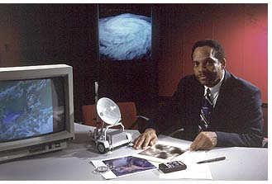
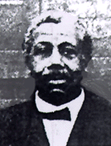

Shirley Ann Jackson (1946-) Walter Eugene Massey (1938-)
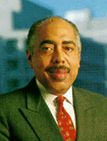
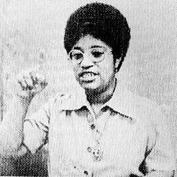

Ronald Erwin McNair (1950-1986)
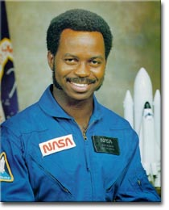

Matching Quiz
Below are some key facts about the physicists you have just studied.
Match each physicist with the facts that apply to him/her.

a) First African American woman to receive PhD in physics from Massachusetts Institute of Technology (MIT)
b) Second African American to fly in Space
c) Served as Director of the Nuclear Regulatory Commission under Bill Clinton
d) Served as Director of Argonne National Laboratory
e) Served as Director of the National Science Foundation
f) The current President of Rensselaer Polytechnic Institute
g) Served as President of Morehouse College
h) First African American to receive a PhD from any American University
i) A national TRIO program to increase graduate degree awards for students from underrepresented segments of society is named in his honor.
j) He has over 20 inventions but is best known as the inventor of the imaging x-ray spectrometer –a device that helps scientists better understand what materials are composed of when they cannot be broken down

Answers to quiz
- Edward Bouchet (h)
- George Alcorn (j)
3) Shirley Ann Jackson ( a,c,f)
4) Walter Massey (d,e,g)
5) Ronald E. McNair (b,i)

